# CS 340 README Matthew R. Leclerc

This project aims to develop a software application that will assist one international company, Grazioso Salvare, targeted at training rescue animals in finding and categorizing dogs fit for searching and rescuing. The application interacts with data provided by animal shelters to identify dogs based on the appropriate profiles and criteria such as age, breed, etc. The project further includes the development of a MongoDB database and a Python module that will come in handy in CRUD operations on this database.

## Getting Started

To start with this program, you would first:

1. Usage Instructions Clone Repository: Clone a GitHub repository to the local machine.
2. Install Dependencies: install with pip all required dependencies.
3. Set up MongoDB: Make sure you have an instance of MongoDB up and running and accessible.
4. Update Connection Details: Update the connection details of the MongoDB of the CRUD module.
5. Execute Script: Run the following examples in order to perform CRUD operations on your MongoDB database.
6. Import the CSV file aac_shelter_outcome.csv to Mongo using a mongoimport.
7. One would then want to create a simple and complex index to parse the data stored within the document.
8. Now, after that, for authentication, I would have to create both an **Admin** account and an **accuser** account to access the database.
9. 4. Then, a user would have to be able to access or install Python and run the program out of a notebook.

## Installation

The user would be required to have installed MongoDB and a Current version of Python to run the .py and the .ipynb files. For the Python file, the installation needed an IDE, which might be Jupyter Notebooks or maybe even Spyder/Anaconda or another IDE.

The official driver for MongoDB used to make operations is Pymongo. pymongo is an efficient and powerful official MongoDB driver for Python, providing a wholesome way of interfacing applications and databases. That is why I have decided to include it in this project: its reliability, complete documentation, and acceptance by many developers in the Python community.

To install, the user would use the following command in the command prompt: *pip install pymongo*

## Usage

### Code Example

This code makes it possible to test, insert, remove, and update animals in a shelter.

### Tests

These are the functionalities that the CRUD module affords:

**Create:**

The create method adds a new document to the specified collection. Method: def create(self, document):

Parameters **document**: A dictionary representing the document to be inserted into the collection.

Example:

data_to_insert = {

"name": "Hotch",

"species": "Dog",

"breed": "German Shorthaired Pointer",

"age": 3

}

created = crud.create(data_to_insert)

print("Create operation result:", created)

**Read:**

The read method retrieves documents from the collection that match the given query. Method: def read(self, query):

Parameters **query**: A dictionary representing the query criteria for retrieving documents.

Example:

query = {"species": "Dog"}

results = crud.read(query)

print("Read operation results:")

for result in results:

print(result)

**Update:**

The update method updates documents in the collection that match the given query with new values. Method: def update(self, query, new_values):

Parameters:

**query**: A dictionary representing the query criteria for selecting documents to update.

**new_values**: A dictionary representing the new values to update the selected documents.

Example:

query_update = {"name": "Hotch", "age": 3}

new_values = {"age": 4}

updated = crud.update(query_update, new_values)

print("Update operation result:", updated)

**Delete:**

The delete method deletes documents from the collection that match the given query. Method: def delete(self, query):

Parameters:

**query:** A dictionary representing the query criteria for selecting documents to delete.

Example:

query_delete = {"name": "Fluffy"}

deleted = crud.delete(query_delete)

print("Delete operation result:", deleted)

## Dashboard Functionality

The dashboard includes the following features:

* **Interactive Filter Options:** Allows filtering the data based on different rescue types (Water Rescue, Mountain/Wilderness Rescue, Disaster Rescue, and Reset).
* **Data Table:** Dynamically responds to the filtering options and displays the relevant records.
* **Geolocation Chart:** Displays the location of selected animals on a map.
* **Pie Chart:** Displays the preferred breeds of animals based on the filtered data.

### Screenshots

Creation of an animal:

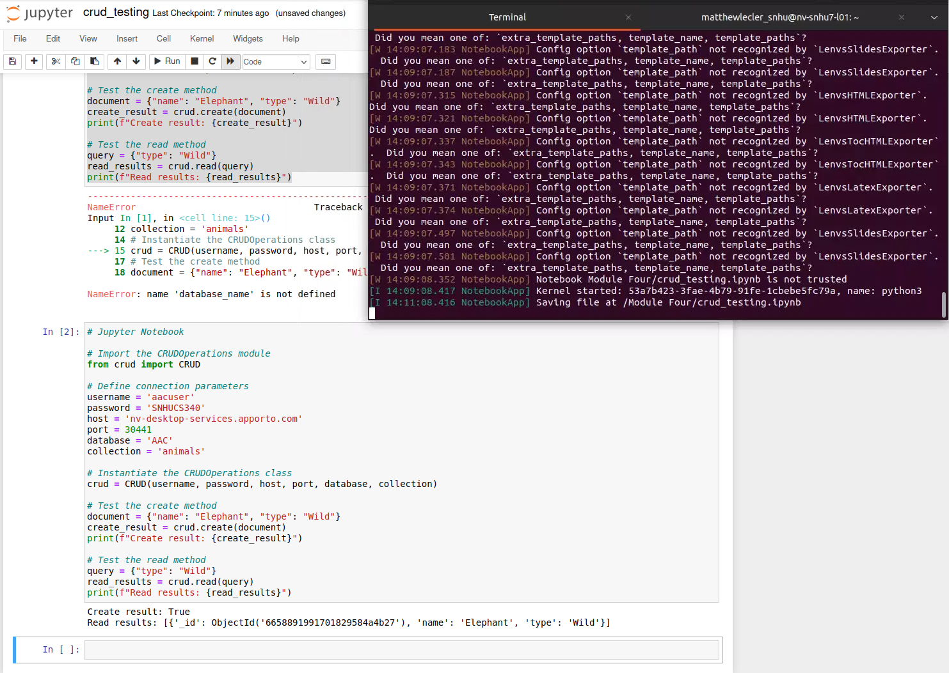

Creation of a dog (Breed German Shorthaired Pointer) named Hotch (Age 3) (My actual dog)

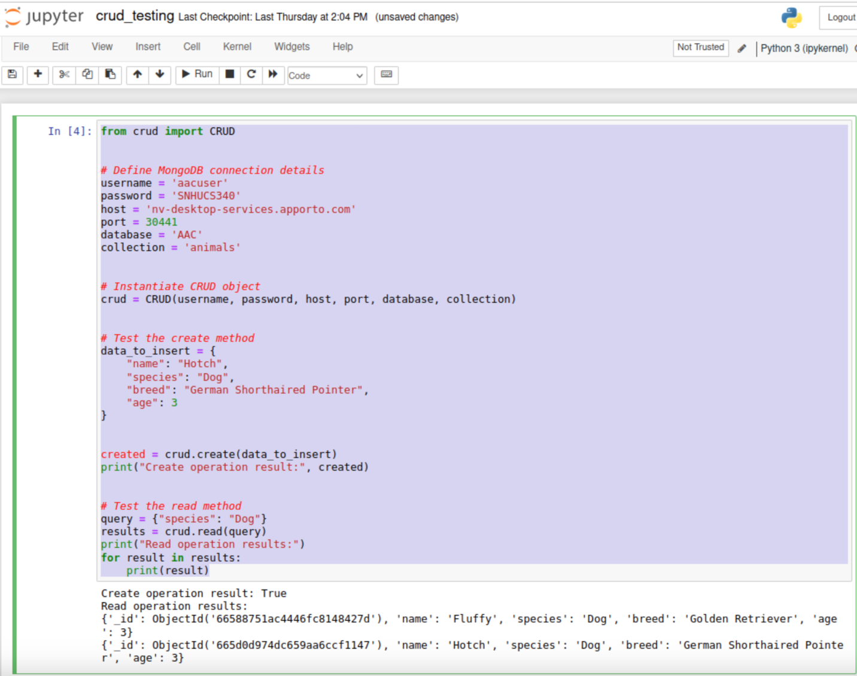

## Error occurring when searching for invalid animal type:

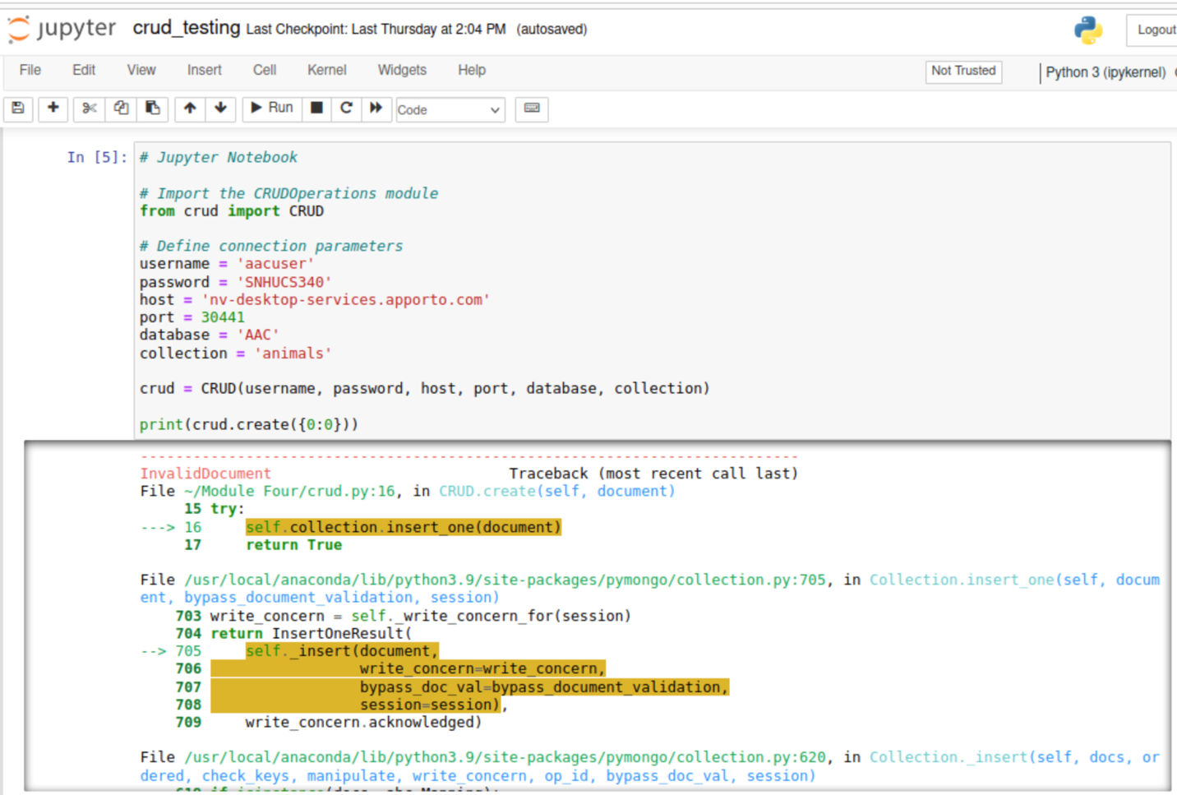

**Updating the Age of my Dog for 3 to 4 & Removing a Dog (Fluffy) from the Database:**

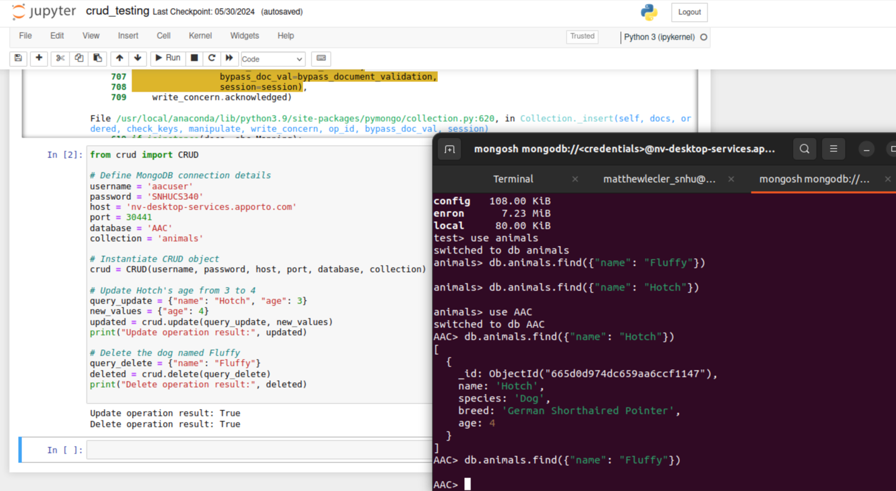

## Dashboard Loadup:

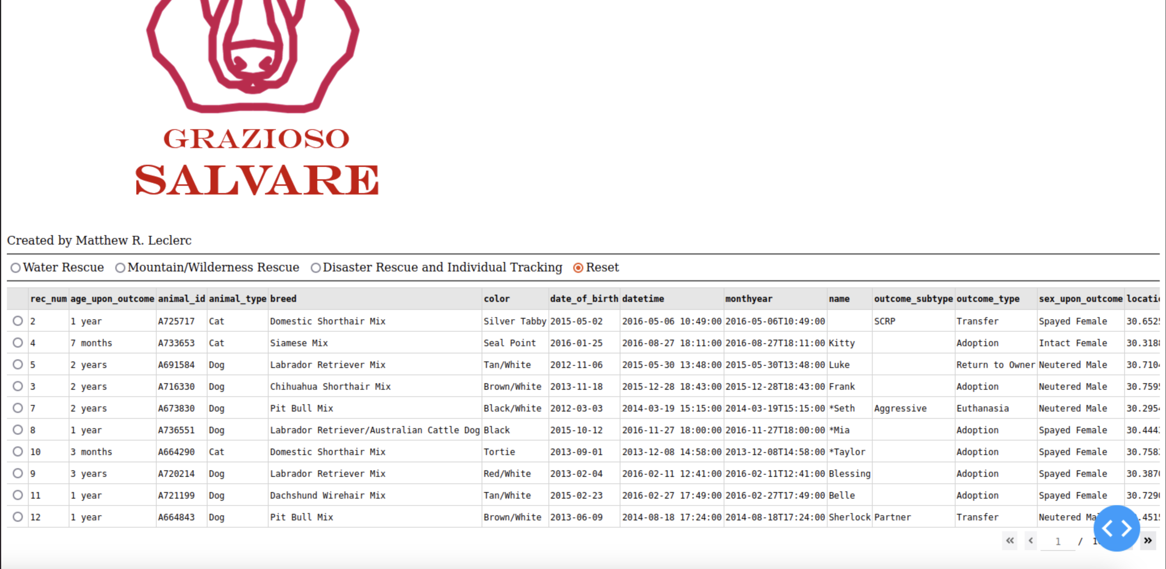

## Water Rescue Filter:

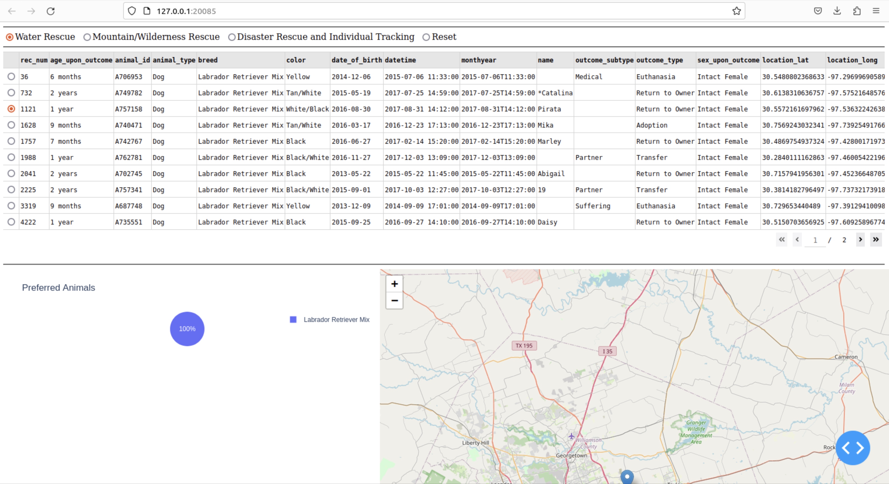

## Mountains/Wilderness Rescue Filter:

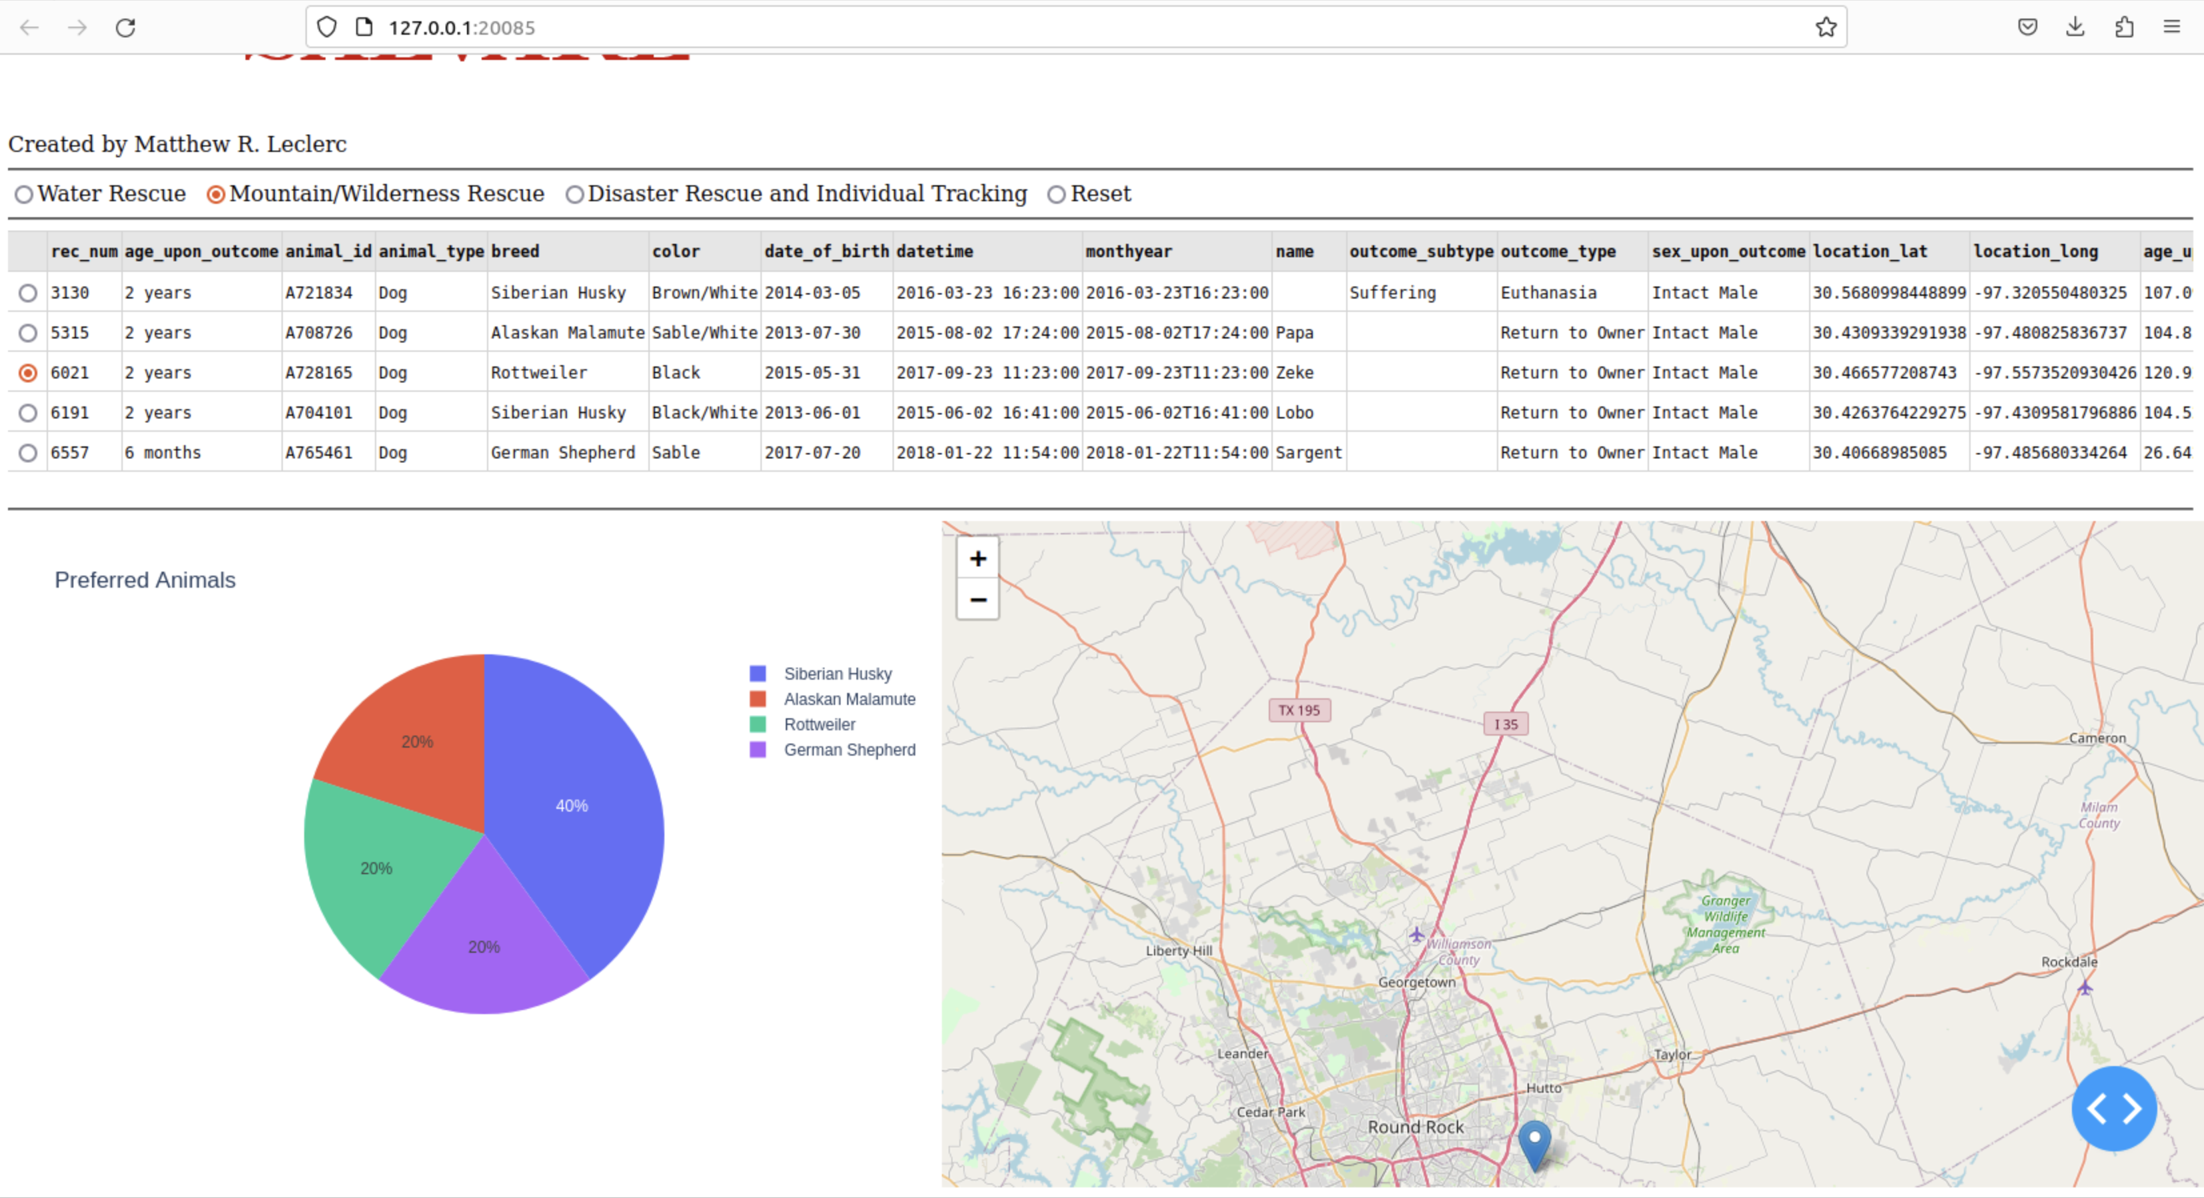

## Disaster Filter:

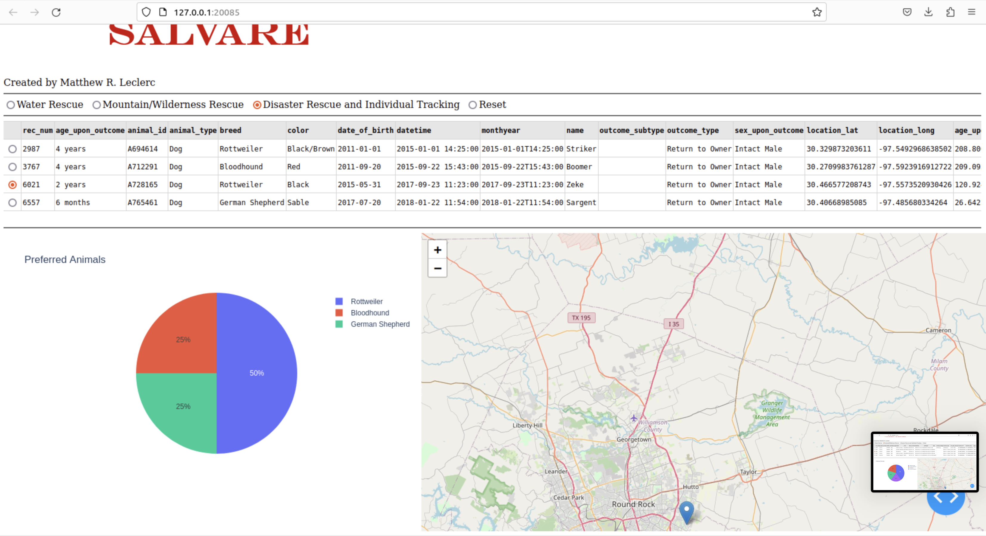

## Challenges:

### Challenge: Data Filtering

Filtering data dynamically and ensuring the dashboard components update correctly was challenging.

**Solution:** Utilized Pandas for efficient data manipulation and ensured callback functions in Dash were correctly implemented to handle data updates.

### Challenge: Map Integration

Integrating the geolocation data into an interactive map was complex due to varying data formats.

**Solution:** Used Dash Leaflet for its compatibility with Dash and ease of integration with geolocation data.

### Challenge: Ensuring Data Integrity

Ensuring the integrity of data fetched from MongoDB and handling missing or inconsistent data.

**Solution:** Implemented comprehensive error handling and data validation within the CRUD operations and dashboard callbacks.

## Contact

Matthew R. Leclerc